|  |  |
| --- | --- |
| **Practicum Case** |  |
| GAME6043  3D Modeling for Games |
| **Computer Science** | **O161-GAME6043-DF01** |
| ***Valid on*** *Odd Semester Year 2018/2019* | **Revisi 00**  *Revision 00* |

**Learning Outcomes**

* Construct : Construct a low-poly 3D model
* Discover : Discover many ways to solve creating models

**Topic**

* Session 03 – Modifier & Polygon Optimization

**Sub Topics**

* Object Modifier
* Common Modifier for Games
* Merging Object
* Stitched and Floating Geometry

## Tutorial

*Tutorial*

**3DS MAX**

* Object Modifier

Modifiers are parametric model tools that change the structure and surface appearance of objects, e.g.: twist, taper, ripple, wave, lathe, extrude objects, and so on (Matossian, 1999).

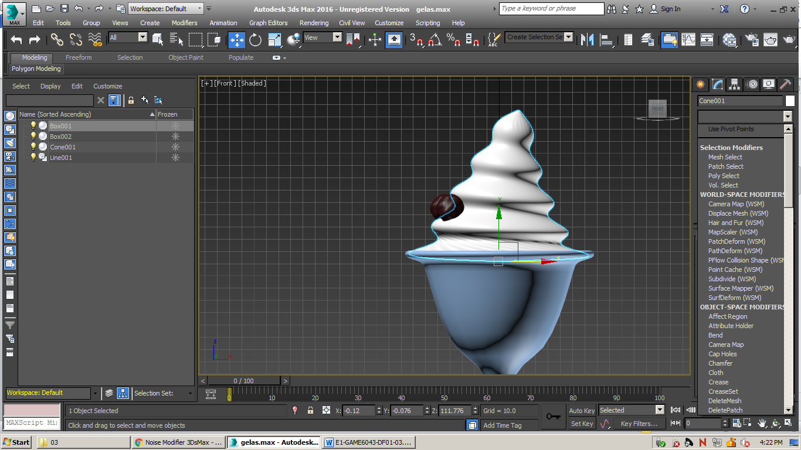

Select the object 🡪 open Modify panel 🡪 select the modifier that you want to apply 🡪 and the parameter of modifier will appear.



There are more than 60 modifiers ship that provided by 3DS MAX on the Modify panel. The following are the Common Modifier for Game Modeling:

* Geometric Modifiers

Geometric modifiers deform objects by moving vertices with respect to the axes of a gizmo, i.e.: Bend, Taper, Skew, Twist, and Stretch.

* Displacing Surfaces

Displacing Surfaces is used to give the random noise effect on the object surfaces, i.e.: Noise, Wave, and Ripple.

* XForm Modifiers

When the object modified and we want to apply transformation in it, the size of object will not transform normally. Therefore, we need to use XForm modifier to apply transformations (Move, Rotate, and Scale) to objects.

* Altering Surface Complexity

You can use the Tessellate modifier to control the complexity of a primitive by adjusting the object segment and combine it with the MeshSmooth or Smooth modifier to control the rounded corners of an object.

* Modifying Splines

You can create 3D object by extruding, lathing, or beveling splines. The complexity of the result object is determined by the number of vertex points on the original spline and setting in each modifier.

Multiple modifiers can be applied in succession to obtain cumulative results.

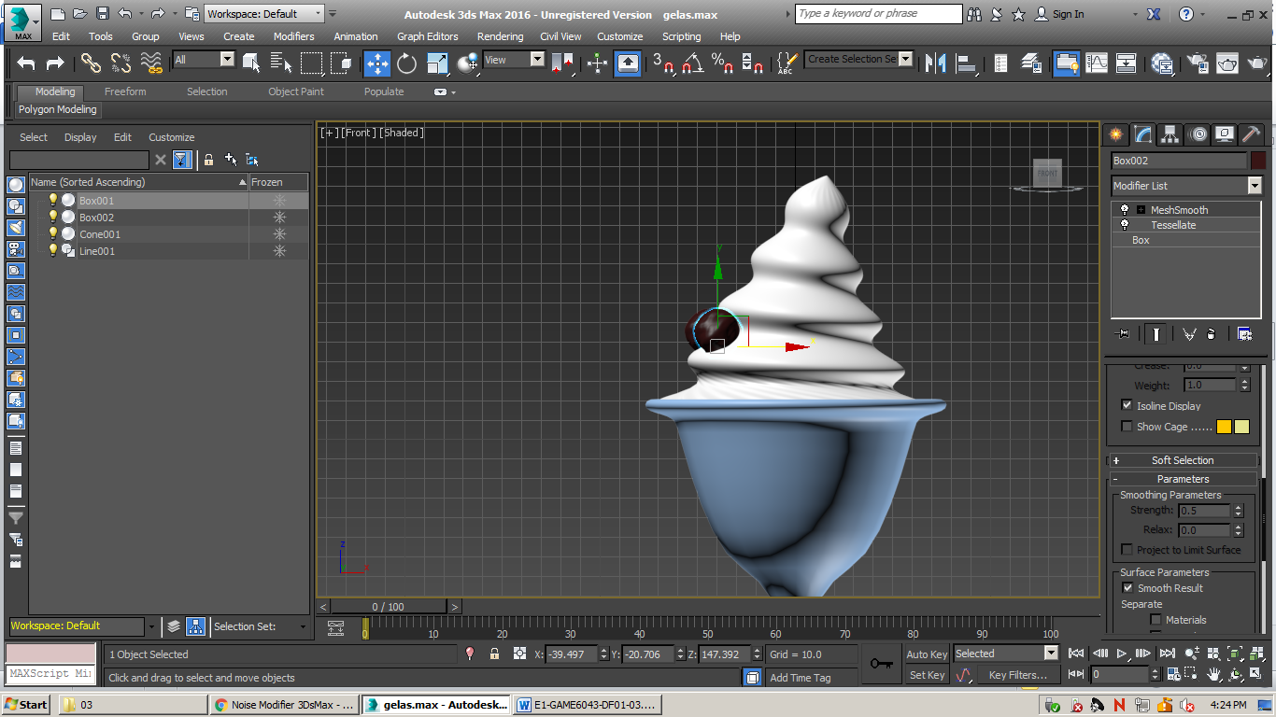

The effect that modifiers have on an object depends upon the order in which they are applied. To rearrange the order of modifiers, you can edit the modifier stack using the cut, copy, and paste commands, and when you satisfied with your modifications, you can collapse the modifier stack (after collapse the modifier stack you can’t edit the modifier stack again, and convert the object to editable poly).

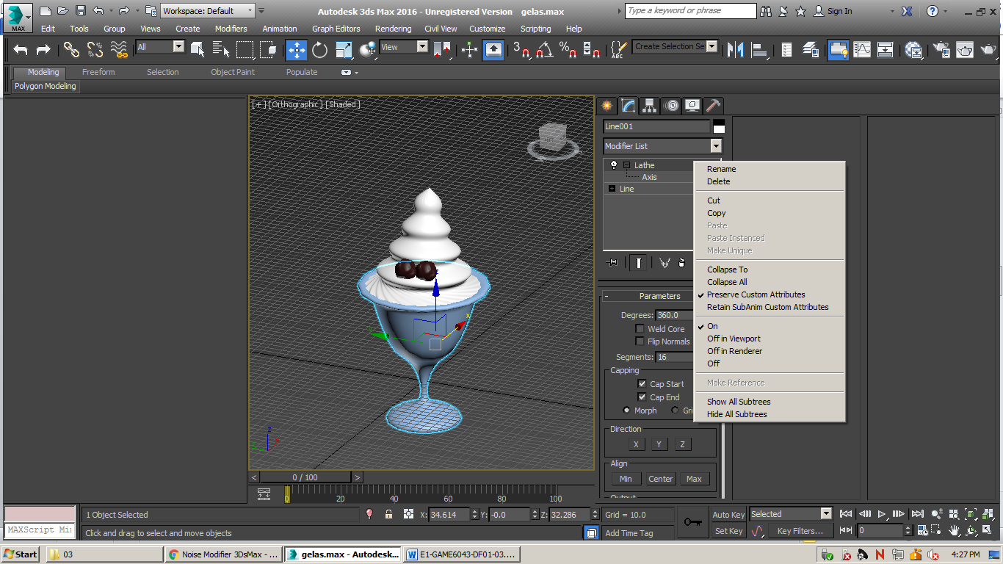

* Merging Object

We can combine 2 or more object into one using compound object. When you apply a compound object command to individual object, the objects become operands of the compound object operation (On the create panel).

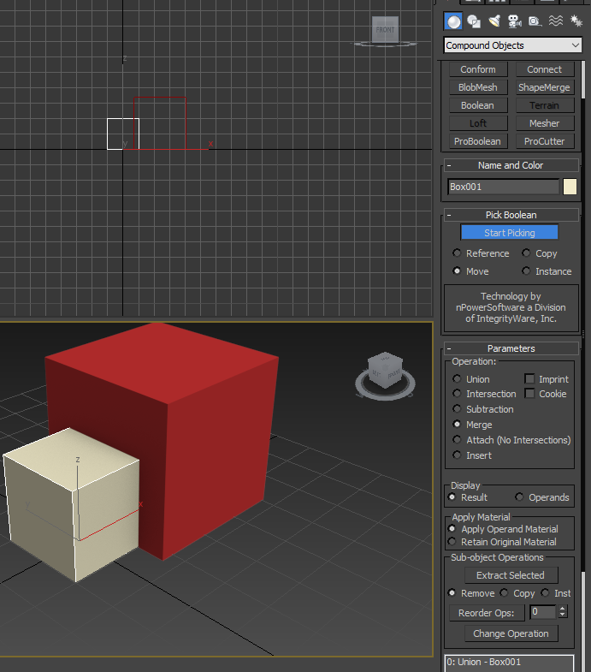

On the compound object there is a Boolean or Proboolean parameter, it used to change the object to the Boolean or Proboolean object. The following are the operation that we can use to change the Boolean object:

* Union 🡪 to combine operands A and B in to one object and removes intersecting face.
* Subtraction (A-B) 🡪 to subtract the volume of operand B from the volume of operand A, build an interior surface on operand A by adding the enclosed faces of operand B to it, and deletes the rest of operand B’s faces.
* Subtraction (B-A) 🡪 otherwise functioning from Subtraction (A-B).
* Intersection 🡪 to takes the overlapping volume of two operands and deletes any nonintersecting volume.
* Cut 🡪 cuts open the surface of operand A with volume of operand B.

**If you don’t understand, please ask your assistant!**

## Soal

*Case*

1. Modelling a cup of ice cream object using Object Modifier!
2. Create the glass using line and lathing.
3. Create the ice using cone and added by Twist, MeshSmooth, and Bend Modifier.
4. Create the chocolate ball using box and added by Tessellate and MeshSmooth.
5. Duplicate the chocolate ball object.
6. 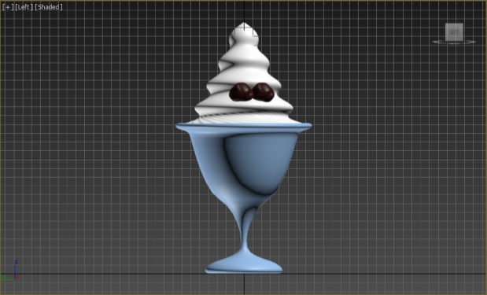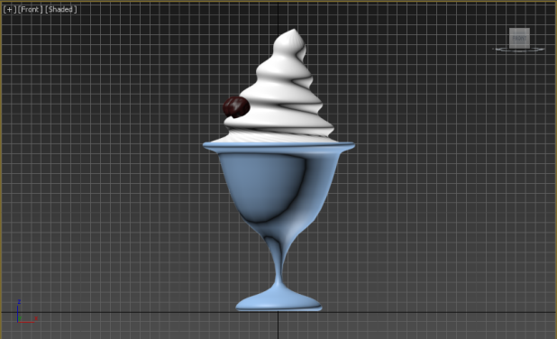For the detail you can see the result by the images below:

Image 1 Front View

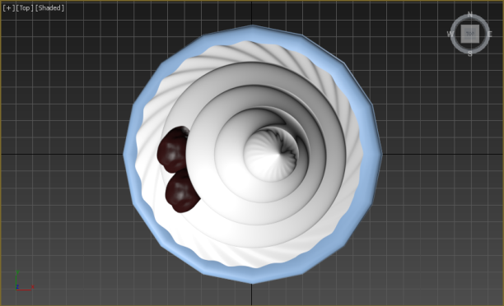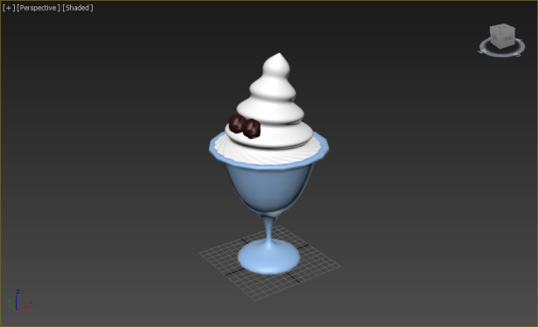

Image 4 Left View

Image 3 Top View

Image 2 Perspective View

1. Modelling the dice object using Merging Object!
2. Create the box with 3rd segments and same length for each side.
3. Added by MeshSmooth Modifier.
4. Create sphere for the roundness effect in dice sides. And use the Boolean or Proboolean objects to merge the box and the sphere object.
5. 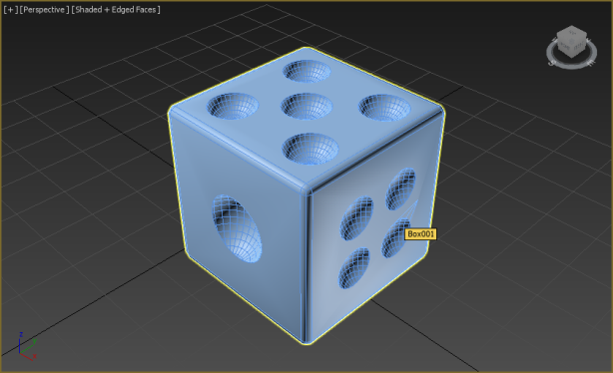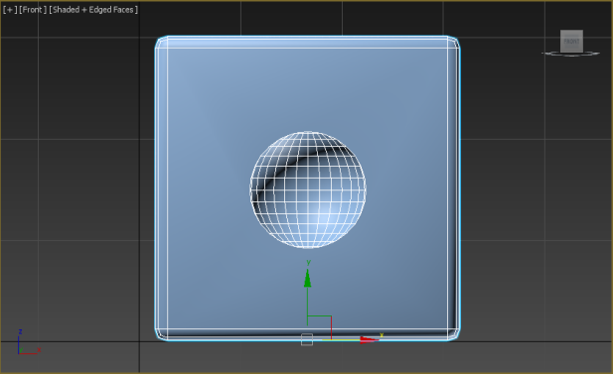For the detail you can see the result by the images below:

Image 1 Front View

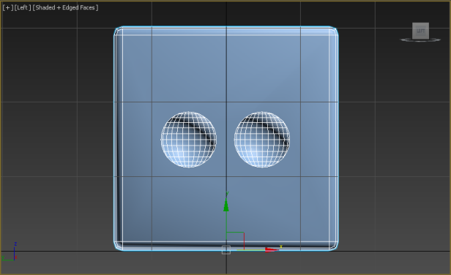

Image 3 Top View

Image 2 Perspective View

Image 4 Left View

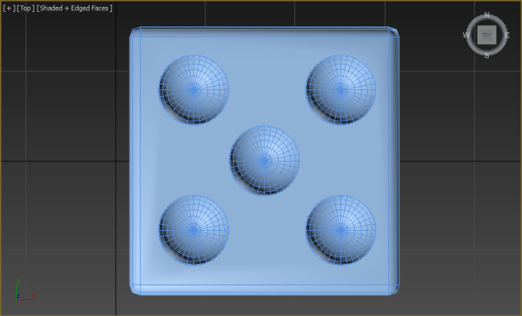

## Referensi

*Reference*

https://knowledge.autodesk.com/support/3ds-max/learn-explore/caas/CloudHelp/cloudhelp/2016/ENU/3DSMax/files/GUID-44AA1775-4215-423B-9D78-7E74CD3D4423-htm.html

https://www.youtube.com/watch?v=oAzbXq_1IaY

https://www.youtube.com/watch?v=7NY-LvEuXWg

https://www.youtube.com/watch?v=ZsI2FsNshUg

Matossian, M. (1999). *3D Studio Max.* United States of America: Visual QuickStart Guide.